**Coursework 2- Social Networking Website**

**Name: Dristi Bhugun**

**Student ID: M00846514**

**Module: CST 2120 Web Application**

**Date of submission: 26/01/24**

**Tutor: Mrinal Sharma**

**TABLE OF CONTENTS**

Introduction 3

How to use TrekTeller? 3

How TrekTeller display posts? 4

Wireframes 5

Database Structure 11

Conclusion 12

**TABLE OF FIGURES**

1 HomePage 1 5

2 HomePage 2 6

3 HomePage 3 6

4 SignUp Page 7

5 Login Page 7

6 HomePage to Signed In users 8

7 Posts - Details 8

8 Posts - Comments 9

9 Chats 9

10 Profile Section 10

11 Database and Collection 11

12 users collection 11

13 posts collection 12

# Introduction

Welcome to TrekTeller, a vibrant community where travel enthusiasts from around the world converge to share their adventures, tips, and wanderlust-driven tales. Whether you're a seasoned globetrotter or a budding explorer, our platform invites you to connect with like-minded individuals, offering a space to post your travel plans and captivating blogs. With an intuitive design and interactive features, TrekTeller, crafted using HTML, Tailwind CSS, JavaScript, AJAX, Node.js, and MongoDB, ensures a seamless and engaging user experience. Join us on this digital journey, where every click unveils a new destination and each post sparks inspiration for your next adventure.

As you navigate through TrekTeller, you'll discover a user-friendly interface that encourages interaction. Login and Sign-Up effortlessly using Node.js and MongoDB, and delve into a world of travel insights. Engage with fellow explorers through likes, comments, and shares, transforming your digital presence into a travel narrative that resonates with others. Our navigation bar simplifies your exploration, guiding you to pages such as 'About Us,' 'Login,' ‘Signup’ and the essential 'Home' button. With a commitment to fostering connections, recognizing achievements, and sparking wanderlust, TrekTeller is your go-to destination for all things travel. Unpack, share, and explore – Adventure Awaits!

# How to use TrekTeller?

**Signup for TrekTeller**

* Go to signup page
* Enter username, email and password to create an account
* Click on Signup button.
* Your account will be created

**Login**

* Go to login page
* Enter your username and password for login the website.
* Click on login button

**Posts**

* Users can view posts of any user and use filter according to continents
* Users can like and comment on any post.

**Post a story**

* Any registered user can post a story and it will be displayed to users.
* Users can upload images in posts to make it attractive.

**Chat**

* Users can message to each other in this website.

# How TrekTeller display posts?

* TrekTeller will scrape some travel websites to get posts using axios, cheerio or beautiful soup and store that in a JSON format.
* After storing all posts in MongoDB, an API will fetch data from Database and it will be rendered in front-end.
* Similarly, API routes will be created for signup, login or display user’s profile.
* Popular posts will be sorted using likes and then it’ll be displayed on posts section or in sidebar.
* Image URL will be stored in database and it’ll fetch image from server or local.

# Wireframes

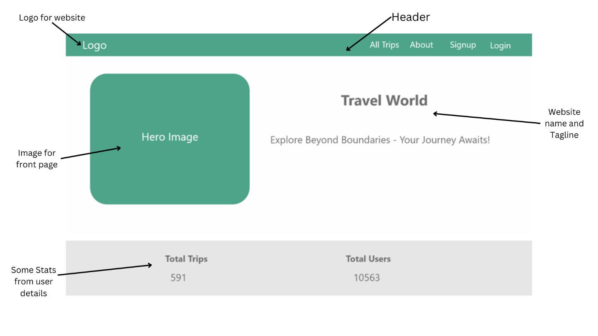

1 HomePage 1

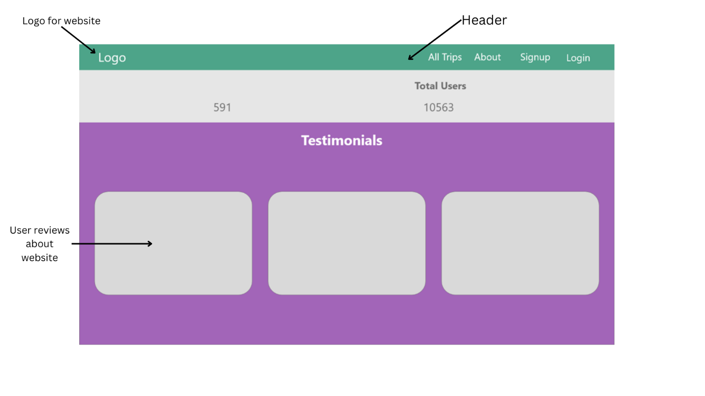

2 HomePage 2

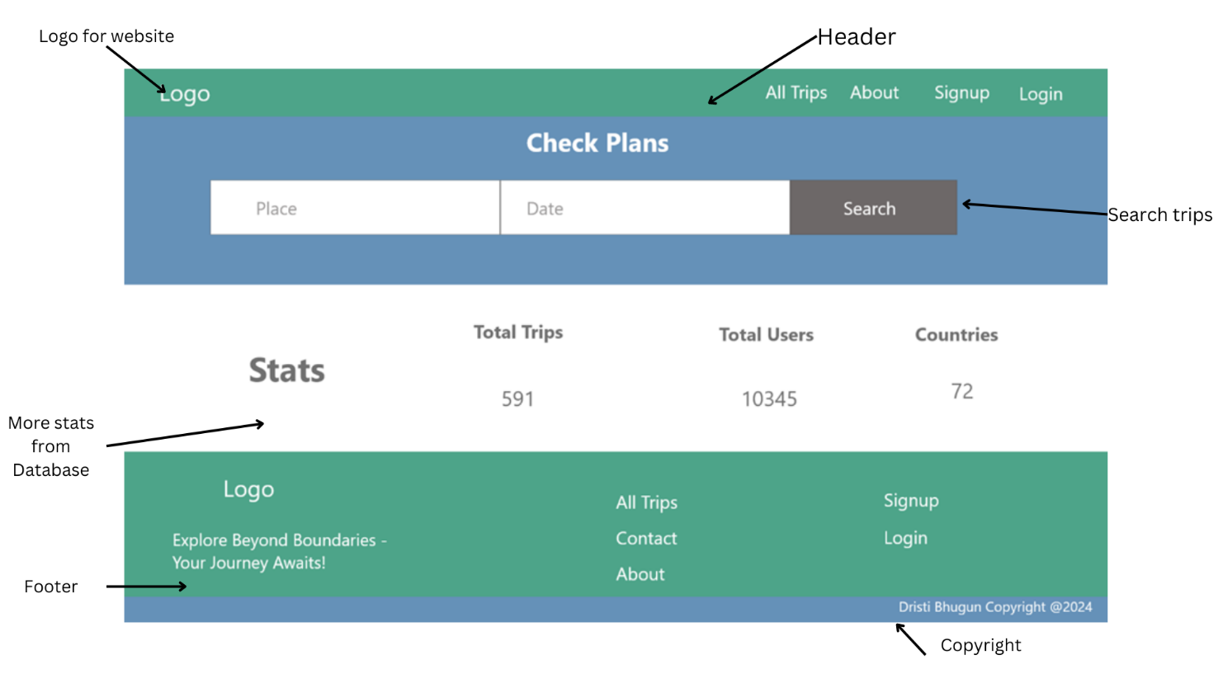

3 HomePage 3

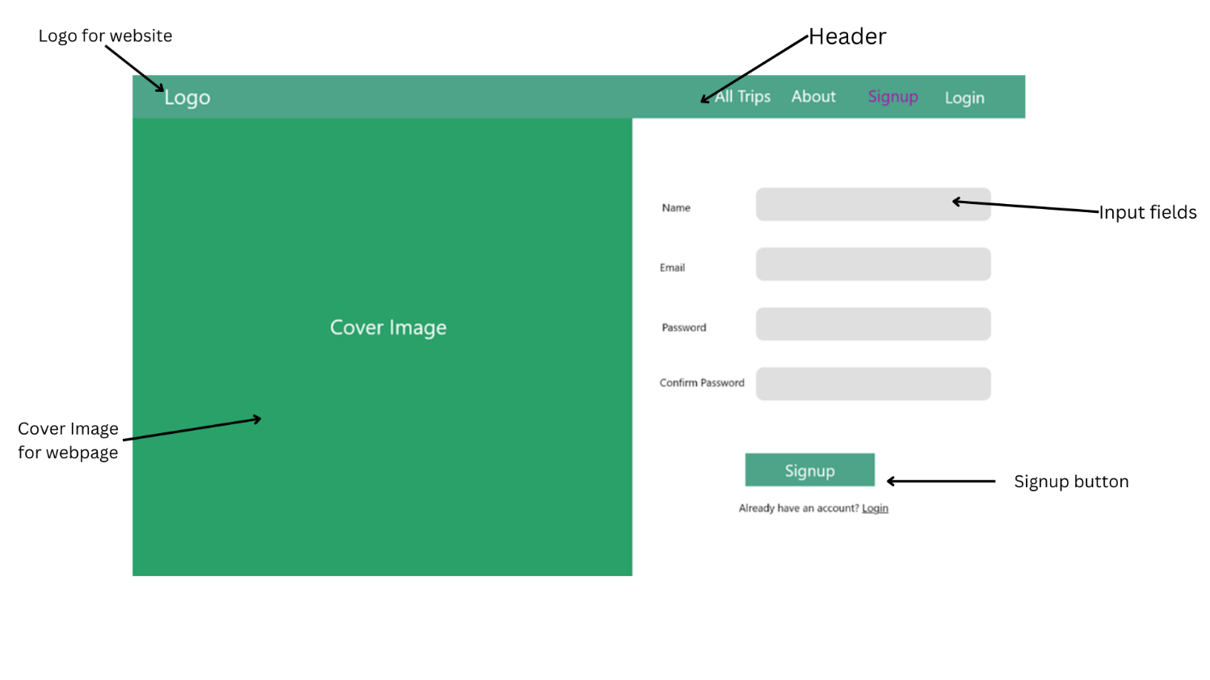

4 SignUp Page

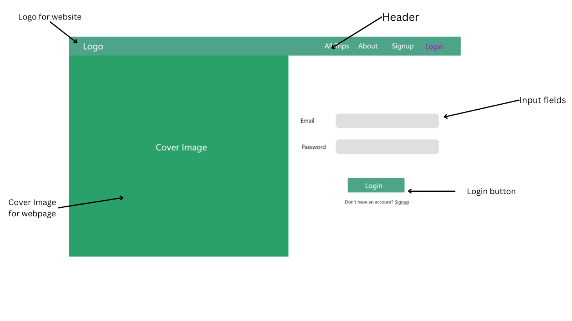

5 Login Page

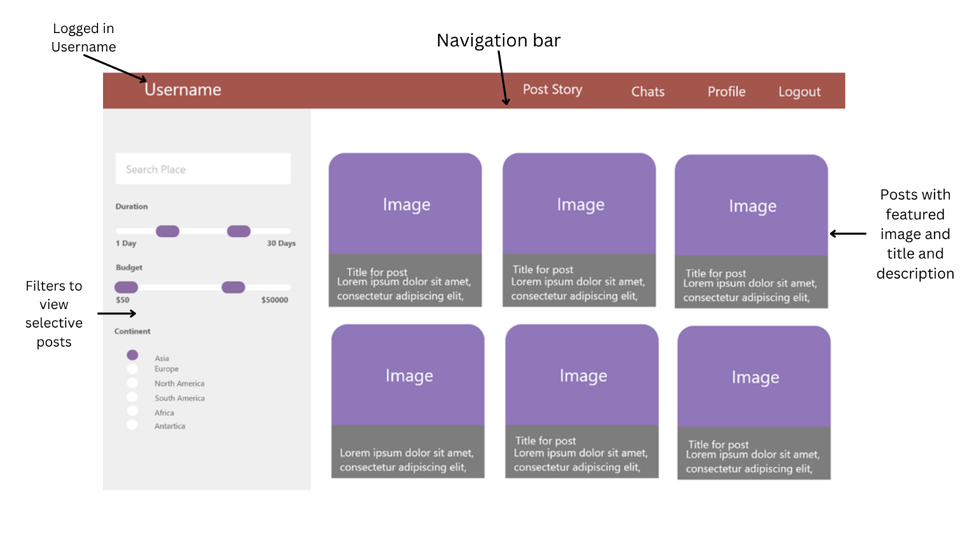

6 HomePage to Signed In users

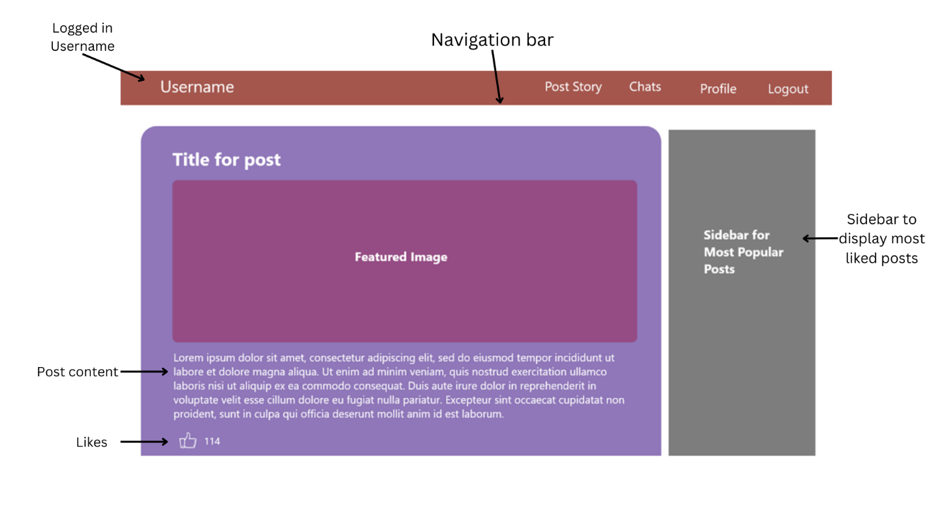

7 Posts - Details

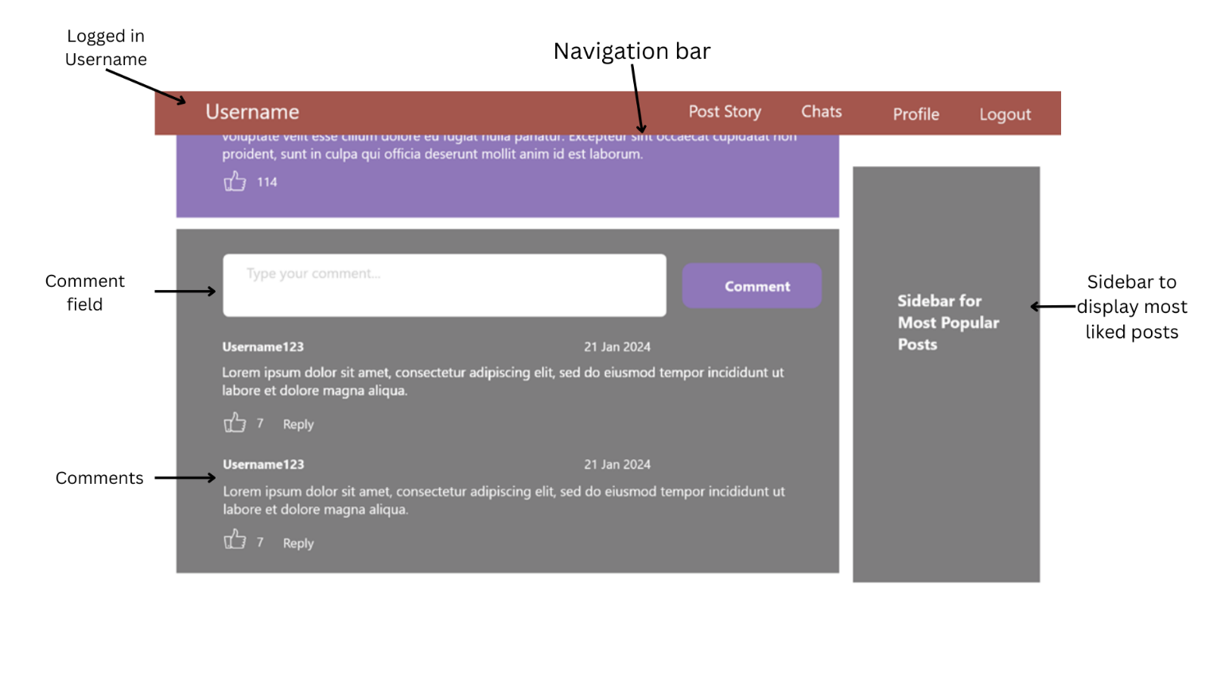

8 Posts - Comments

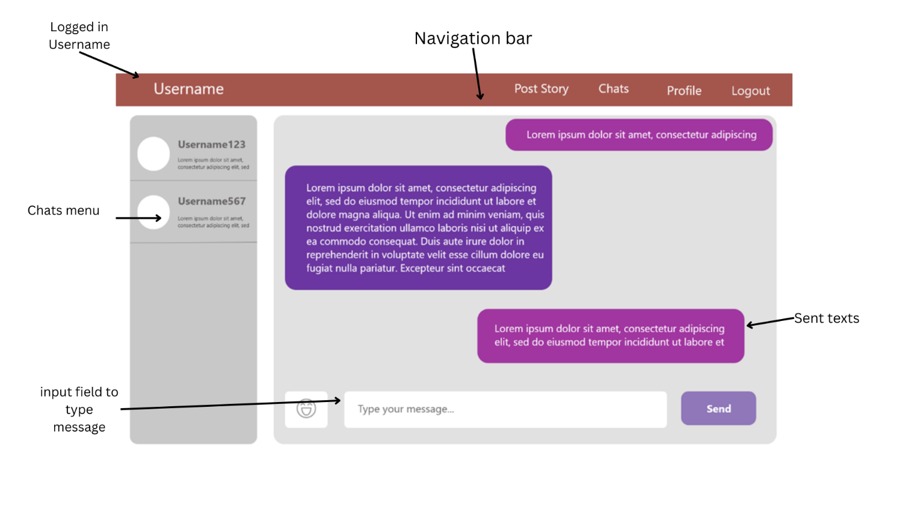

9 Chats

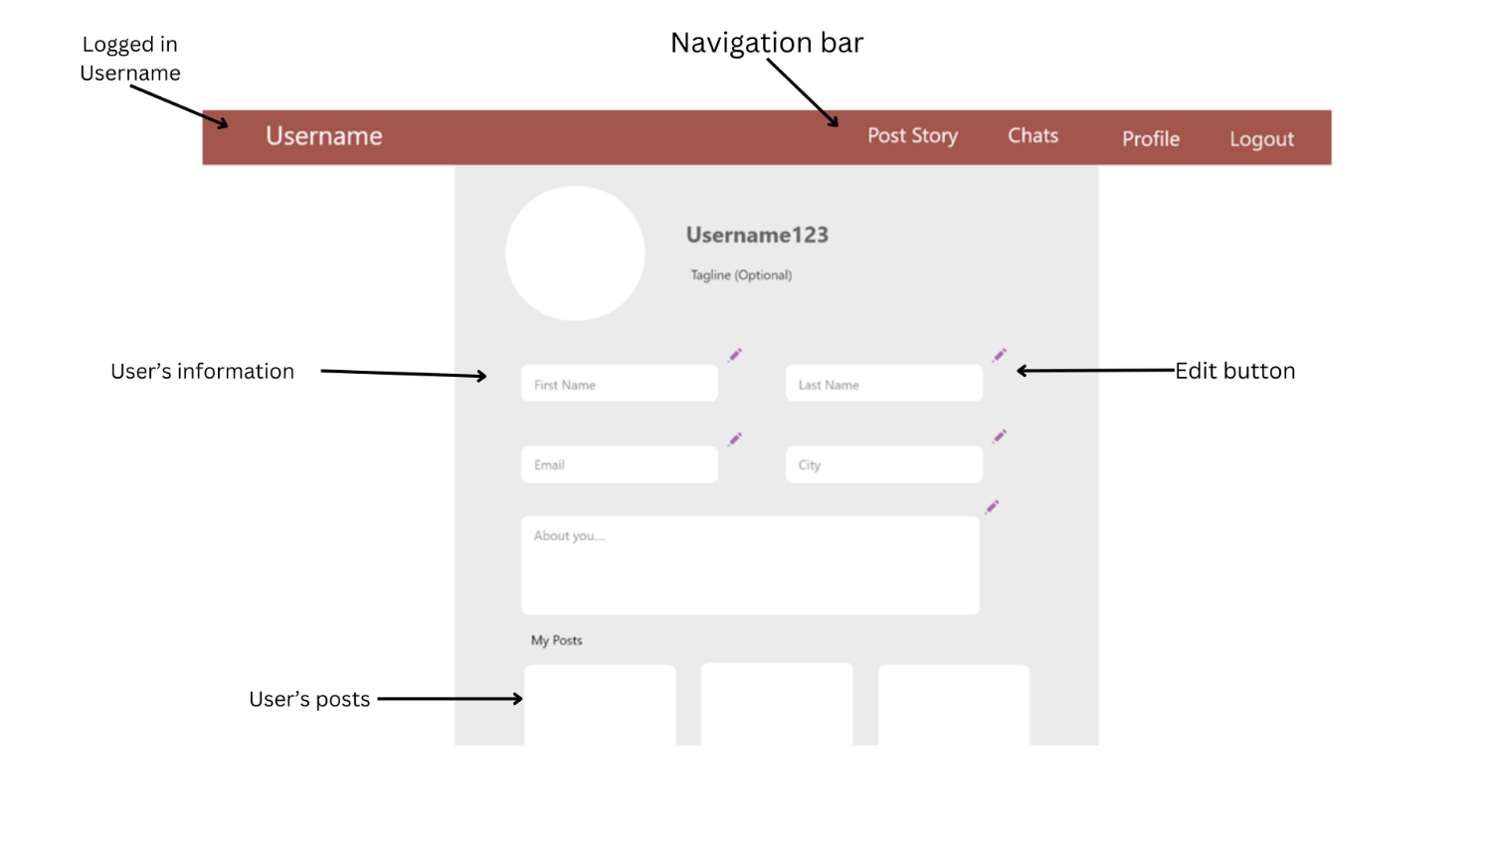

*10* Profile Section

# Database Structure

Database name: ***TrekTeller***

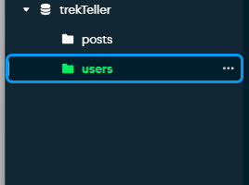

11 Database and Collection

Collection names:

* ***users***

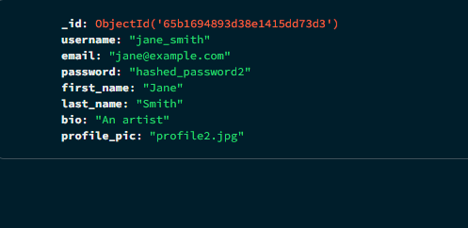

12 users collection

* ***posts***

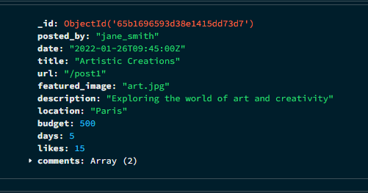

13 posts collection

# Conclusion

In wrapping up our journey through the digital landscape of TrekTeller, we return to the core of what makes this platform not just a hub for travel stories, but a technical marvel in the realm of web-based applications. Leveraging the latest in web development technologies – HTML, Tailwind CSS, JavaScript, AJAX, Node.js, and MongoDB – TrekTeller stands as a paragon of modern web application design, ensuring a seamless, responsive, and engaging user experience.